# CS255 22EW2

# Project Two

**Jared Smith**

**12/07/22**

## UML Diagrams

### UML Use Case Diagram

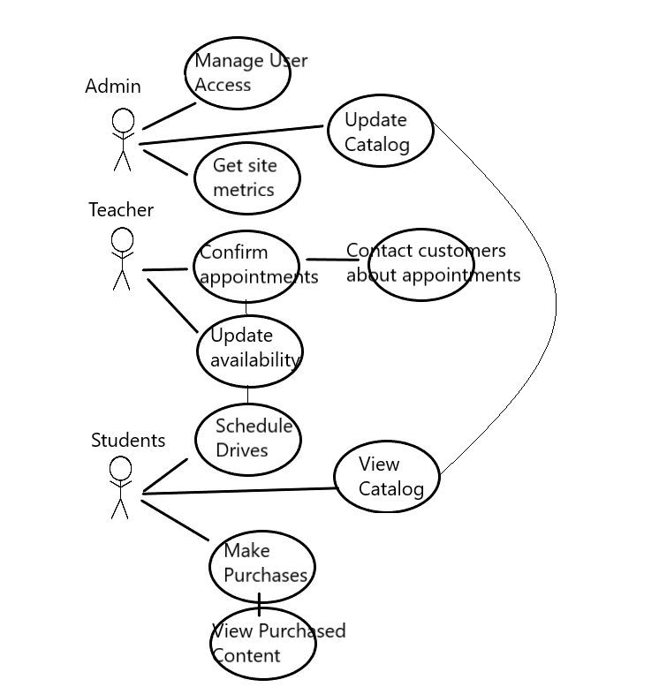

### UML Activity Diagrams

### UML Sequence Diagram

### UML Class Diagram

## Technical Requirements

Infrastructure required for this system include a database that can maintain a repository of calendar appointments and catalog items. If this database is secure, it can also contain user information, such as passwords, usernames, username and payment methods. We will also need a website structure that will allow easy updating and modification of our catalog. We will also need a secure payment processor, which will likely come built in with whatever web building service we choose. Lastly, we will need a way to import a calendar that can take a variety of parameters for each day, so a well-maintained schedule of drives can be maintained.